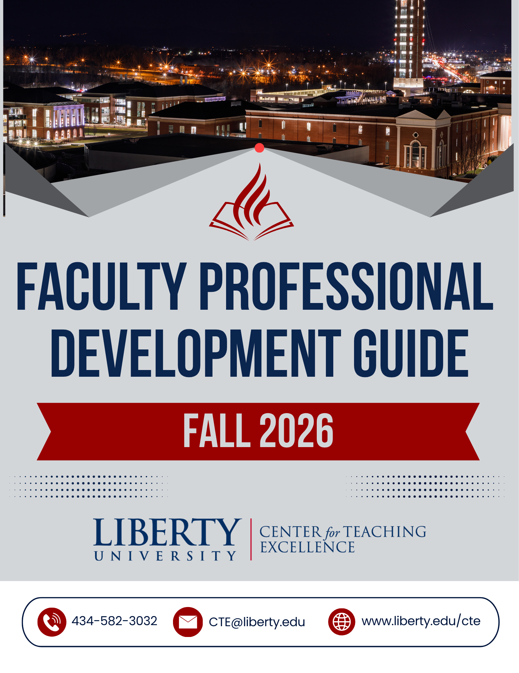

Register for workshops/webinars via the Course Registration tool in myLU (Subject Code: PDCT). Email cte@liberty.edu with questions.
CTE Virtual Open Office Hours; Tuesday, Aug. 18, 25
Noon-4:30 p.m. No registration required. Log on: MS Teams
New Faculty Orientation; Tuesday, Aug. 11, and Friday, Aug. 14
Tuesday, Aug. 11, 8 a.m.-4:30 p.m.; Terrace Conference Room, Jerry Falwell Library
Friday, Aug. 14, 8 a.m-4:30 p.m.; DeMoss Hall, Room 3066
All-Faculty Orientation; Wednesday, Aug. 12
8:45 a.m.-3 p.m.; Montview Alumni Ballroom
Canvas for Teachers; Friday, Aug. 14
9-11:30 a.m.; DeMoss Hall, Room 3066
Canvas for Designers; Friday, Aug. 14
12-2:30 p.m..; DeMoss Hall, Room 3066
Getting Started with Top Hat; Tuesday, Aug. 18
10:30-11:15 a.m.; DeMoss Hall, Room 3066 and MS Teams
Tech Tips for the First Week of Class: Wednesday, Aug. 19
10:30-11:15 a.m.; DeMoss Hall, Room 3066 and MS Teams.
Setting Up and Recording with MS Teams; Thursday, Aug. 20
10:30-11:15 a.m.; DeMoss Hall, Room 3066 and MS Teams
Present Like a Pro: Using Effective Vocal Presentation to Capture Student Engagement: Pt. 1; Friday, Aug. 21
10:30-11:15 a.m.; DeMoss Hall, Room 3066 and MS Teams
Canvas Basics for the First Week of Class; Monday, Aug. 24
10:30-11:15 a.m.; DeMoss Hall, Room 3066 and MS Teams
Virtual Prayer Session: Fall B-Term; Monday, Aug. 24
Noon-1 p.m. No registration required. Log on: MS Teams
Logos for Educators: Part 1; Wednesday, Aug. 26
Noon-12:45 p.m.; MS Teams
Online Teaching Exchange; Thursday, Aug. 27
Noon-1 p.m.; MS Teams
Communicating with Students About AI and Academic Integrity; Friday, Aug. 28
10:30-11:15 a.m.; DeMoss Hall, Room 3066 and MS Teams
Canvas Tools for Communicating with Students; Monday, Aug. 31
10:30-11:15 a.m.; DeMoss Hall, Room 3066 and MS Teams

Register for workshops/webinars via the Course Registration tool in myLU (Subject Code: PDCT). Email cte@liberty.edu with questions.
CTE Virtual Open Office Hours; Tuesday, Sept. 1, 8, 15, 22, 29
Noon-4:30 p.m. No registration required. Log on: MS Teams
Logos for Educators: Part 2; Wednesday, Sept. 2
Noon-12:45 p.m.; MS Teams
Present Like a Pro: Using Effective Vocal Presentation to Capture Student Engagement: Pt. 2; Friday, Sept. 4
10:30-11:15 a.m.; DeMoss Hall, Room 3066 and MS Teams
Creating Assignments, Quizzes, and Rubrics in Canvas; Monday, Sept. 7
10:30-11:15 a.m.; DeMoss Hall, Room 3066 and MS Teams
Using MS Breakout Rooms, Polls, and Reactions: Tools for Interactive MS Teams Meetings Series; Wednesday, Sept. 9
Noon-12:45 p.m.; MS Teams
Creating Question Banks and Question Groups in Canvas; Friday, Sept. 11
10:30-11:15 a.m.; DeMoss Hall, Room 3066 and MS Teams
Recording and Embedding Videos with Kaltura; Monday, Sept. 14
10:30-11:15 a.m.; DeMoss Hall, Room 3066 and MS Teams
Using MS Whiteboard: Tools for Interactive MS Teams Meetings Series; Wednesday, Sept. 16
Noon-12:45 p.m.; MS Teams
Biblical Worldview Integration with Dr. Mark Eckel; Thursday, Sept 17
11:30 a.m.-12:30 p.m.; DeMoss Hall, Room 3066 and MS Teams
Mastering the Complexity of Teaching In-Person and Online Simultaneously; Friday, Sept. 18
10:30-11:15 a.m.; DeMoss Hall, Room 3066 and MS Teams
Virtual Prayer Session: Fall C-Term; Monday, Sept. 21
Noon-1 p.m. No registration required. Log on: MS Teams
The Online Professor’s Relationship with God:
Relational Biblical Worldview Integration (BWI) in Online Teaching Series; Wednesday, Sept. 23
5-5:45 p.m.; MS Teams
Online Teaching Exchange; Thursday, Sept. 24
Noon-1 p.m.; MS Teams
Designing AI Assignments and Activities for Residential Courses; Friday, Sept. 25
10:30-11:15 a.m.; DeMoss Hall, Room 3066 and MS Teams
Tools for Interactive Meetings in MS Teams; Monday, Sept. 28
10:30-11:15 a.m.; DeMoss Hall, Room 3066 and MS Teams
The Online Professor’s Relationship with Ideas:
Relational Biblical Worldview Integration (BWI) in Online Teaching Series; Wednesday, Sept. 30
5-5:45 p.m.; MS Teams

Register for workshops/webinars via the Course Registration tool in myLU (Subject Code: PDCT). Email cte@liberty.edu with questions.
CTE Virtual Open Office Hours; Tuesday, Oct. 6, 13, 20, 27
Noon-4:30 p.m. No registration required. Log on: MS Teams
SpeedGrader Tools for Efficiency and Quality Feedback; Friday, Oct. 2
10:30-11:15 a.m.; DeMoss Hall, Room 3066 and MS Teams
How to Stay Well and Happy: Preventing Faculty Burnout; Monday, Oct. 5
10:30-11:15 a.m.; DeMoss Hall, Room 3066 and MS Teams
The Online Professor’s Relationship with Things:
Relational Biblical Worldview Integration (BWI) in Online Teaching Series; Wednesday, Oct. 7
5-5:45 p.m.; MS Teams
Implementing AI Assignments and Activities in Residential Courses; Friday, Oct. 9
10:30-11:15 a.m.; DeMoss Hall, Room 3066 and MS Teams
Understanding the Course Copy Process; Monday, Oct. 12
10:30-11:15 a.m.; DeMoss Hall, Room 3066 and MS Teams
The Online Professor’s Relationship with People:
Relational Biblical Worldview Integration (BWI) in Online Teaching Series; Wednesday, Oct. 14
5-5:45 p.m.; MS Teams
Leveling Up Your Presentations with PowerPoint; Monday, Oct. 19
10:30-11:15 a.m.; DeMoss Hall, Room 3066 and MS Teams
Understanding AI Literacy in Higher Education: AI Literacy for Online Faculty Series; Wednesday, Oct. 21
Noon-12:45 p.m.; MS Teams
Biblical Worldview Integration with Dr. Roger Schultz; Thursday, Oct. 22
11:30 a.m.-12:30 p.m.; DeMoss Hall, Room 3066 and MS Teams
Tracking Student Progress with Course Analytics in Canvas; Friday, Oct. 23
10:30-11:15 a.m.; DeMoss Hall, Room 3066 and MS Teams
Teaching Students to be Resilient; Monday, Oct. 26
10:30-11:15 a.m.; DeMoss Hall, Room 3066 and MS Teams
Virtual Prayer Session: Fall D-Term; Monday, Oct. 26
Noon-1 p.m. No registration required. Log on: MS Teams
Navigating the Challenges of AI Literacy in Teaching: AI Literacy for Online Faculty Series; Wednesday, Oct. 28
Noon-12:45 p.m.; MS Teams
Online Teaching Exchange; Thursday, Oct. 29
Noon-1 p.m.; MS Teams
AI Tools for Creating Images and Designs; Friday, Oct. 30
10:30-11:15 a.m.; DeMoss Hall, Room 3066 and MS Teams


Register for workshops/webinars via the Course Registration tool in myLU (Subject Code: PDCT). Email cte@liberty.edu with questions..
CTE Virtual Open Office Hours; Tuesday, Nov. 3, 10. 17
Noon-4:30 p.m. No registration required. Log on: MS Teams
Set It and Forget It: Preparing Your Assignment Due Dates; Monday, Nov. 2
10:30-11:15 a.m.; DeMoss Hall, Room 3066 and MS Teams
Strategies for Developing AI Literacy in Students: AI Literacy for Online Faculty Series; Wednesday, Nov. 4
Noon-12:45 p.m.; MS Teams
Taming the Inbox: Efficient Email Management in Outlook; Friday, Nov. 6
10:30-11:15 a.m.; DeMoss Hall, Room 3066 and MS Teams
Using AI To Prepare Students for their Future: AI Literacy for Online Faculty Series; Wednesday, Nov. 11
Noon-12:45 p.m.; MS Teams
Teacher Reflection that Transforms Teaching; Friday, Nov. 13
10:30-11:15 a.m.; DeMoss Hall, Room 3066 and MS Teams
Strategies for Interpreting and Addressing Turnitin AI Reports; Monday, Nov. 16
10:30-11:15 a.m.; DeMoss Hall, Room 3066 and MS Teams
The Art of Crafting AI Prompts:
AI Tools to Streamline Teaching Tasks Series; Wednesday, Nov. 18
5-5:45 p.m.; MS Teams
Biblical Worldview Integration with Dr. Melissa Clemmons; Thursday, Nov. 19
11:30 a.m.-12:30 p.m.; DeMoss Hall, Room 3066 and MS Teams

Save the Dates:
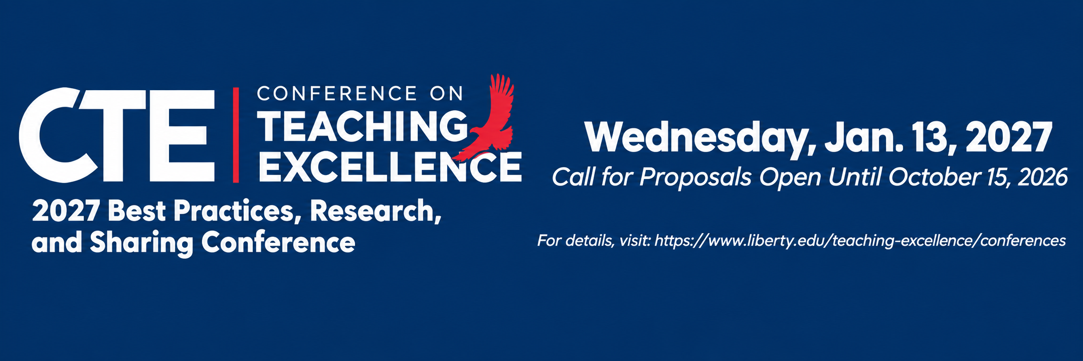

Register for workshops/webinars via the Course Registration tool in myLU (Subject Code: PDCT). Email cte@liberty.edu with questions.
CTE Virtual Open Office Hours; Tuesday, Dec. 1, 8, 15
Noon-4:30 p.m. No registration required. Log on: MS Teams
Optimizing AI for Brainstorming and Planning: AI Tools to Streamline Teaching Tasks Series; Wednesday, Dec. 2
5-5:45 p.m.; MS Teams
Engage and Connect: Designing Custom QR Codes for Teaching; Friday, Dec. 4
10:30-11:15 a.m.; DeMoss Hall, Room 3066 and MS Teams
Leveraging myStudents in Canvas for Student Retention and Success; Monday, Dec. 7
10:30-11:15 a.m.; DeMoss Hall, Room 3066 and MS Teams
Implementing AI Assignments and Activities:
AI Tools to Streamline Teaching Tasks Series; Wednesday, Dec, 9
5-5:45 p.m.; MS Teams
Ensuring Positive Interactions with Students: Handling Incivility in the Classroom; Friday, Dec. 11
10:30-11:15 a.m.; DeMoss Hall, Room 3066 and MS Teams
Saving Time with AI Agents: AI Tools to Streamline Teaching Tasks Series; Wednesday, Dec. 16
5-5:45 p.m.; MS Teams
Online Teaching Exchange; Thursday, Dec. 17
Noon-1 p.m.; MS Teams

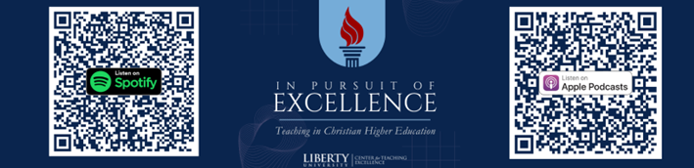



To help you quickly identify professional development sessions that align with your interests, here is a listing of workshops arranged by topic.
Day/Date | Time | Workshop Title
Thursday, Sept. 17 | 11:30 a.m.-12:30 p.m. | Biblical Worldview Integration with Dr. Mark Eckel (All)
Wednesday, Sept. 23 | 5:00-5:45 p.m. | The Online Professor’s Relationship with God: Relational Biblical Worldview Integration (BWI) in Online Teaching Series (All)
Wednesday, Sept. 30 | 5:00-5:45 p.m. | The Online Professor’s Relationship with Ideas: Relational Biblical Worldview Integration (BWI) in Online Teaching Series (All)
Wednesday, Oct. 7 | 5:00-5:45 p.m. | The Online Professor’s Relationship with Things: Relational Biblical Worldview Integration (BWI) in Online Teaching Series (All)
Wednesday, Oct. 14 | 5:00-5:45 p.m. | The Online Professor’s Relationship with People: Relational Biblical Worldview Integration (BWI) in Online Teaching Series (All)
Thursday, Oct. 22 | 11:30 a.m.-12:30 p.m. | Biblical Worldview Integration with Dr. Roger Schultz (All)
Thursday, Nov. 19 | 11:30 a.m.-12:30 p.m. | Biblical Worldview Integration with Dr. Melissa Clemmons (All)
Legend: B = Beginner, I = Intermediate, A = Advanced, or All = All Levels
Day/Date | Time | Workshop Title
Friday, Aug. 21 | 10:30-11:15 a.m. | Present Like a Pro: Using Effective Vocal Presentation to Capture Student Engagement: Part 1 (All)
Thursday, Aug. 27 | Noon-1:00 p.m. | Online Teaching Exchange (All)
Friday, Sept. 4 | 10:30-11:15 a.m. | Present Like a Pro: Using Effective Vocal Presentation to Capture Student Engagement: Part 2 (All)
Friday, Sept. 18 | 10:30-11:15 a.m. | Mastering the Complexity of Teaching In-Person and Online Simultaneously (All)
Thursday, Sept. 24 | Noon-1:00 p.m. | Online Teaching Exchange (All)
Monday, Oct. 5 | 10:30-11:15 a.m. | How to Stay Well and Happy: Preventing Faculty Burnout (All)
Monday, Oct. 26 | 10:30-11:15 a.m. | Teaching Students to be Resilient (All)
Thursday, Oct. 29 | Noon-1:00 p.m. | Online Teaching Exchange (All)
Friday, Nov. 13 | 10:30-11:15 a.m. | Teacher Reflection that Transforms Teaching (All)
Friday, Dec. 11 | 10:30-11:15 a.m. | Ensuring Positive Interactions with Students: Handling Incivility in the Classroom (All)
Thursday, Dec. 17 | Noon-1:00 p.m. | Online Teaching Exchange (All)
Legend: B = Beginner, I = Intermediate, A = Advanced, or All = All Levels
Day/Date | Time | Workshop Title
Tuesday, Aug. 18 | 10:30-11:15 a.m. | Getting Started with Top Hat (All)
Wednesday, Aug. 19 | 10:30-11:15 a.m. | Tech Tips for the First Week of Class (All)
Thursday, Aug. 20 | 10:30-11:15 a.m. | Setting Up and Recording with MS Teams (All)
Monday, Aug. 24 | 10:30-11:15 a.m. | Canvas Basics for the First Week of Class (All)
Wednesday, Aug. 26 | Noon-12:45 p.m. | Logos for Educators: Part 1(B)
Friday, Aug. 28 | 10:30-11:15 a.m. | Communicating with Students About AI and Academic Integrity (All)
Monday, Aug. 31 | 10:30-11:15 a.m. | Canvas Tools for Communicating with Students (All)
Wednesday, Sept. 2 | Noon-12:45 p.m. | Logos for Educators: Part 2 (I)
Monday, Sept. 7 | 10:30-11:15 a.m. | Creating Assignments, Quizzes, and Rubrics in Canvas (All)
Wednesday, Sept. 9 | Noon-12:45 p.m. | Using MS Breakout Rooms, Polls, and Reactions (I)
Friday, Sept. 11 | 10:30-11:15 a.m. | Creating Question Banks and Question Groups (All)
Monday, Sept. 14 | 10:30-11:15 a.m. | Recording and Embedding Videos with Kaltura (All)
Wednesday, Sept. 16 | Noon-12:45 p.m. | Using MS Whiteboard (I)
Friday, Sept. 25 | 10:30-11:15 a.m. | Designing AI Assignments and Activities for Residential Courses (I)
Monday, Sept. 28 | 10:30-11:15 a.m. | Tools for Interactive Meetings in MS Teams (I)
Friday, Oct. 2 | 10:30-11:15 a.m. | SpeedGrader Tools for Efficiency and Quality Feedback (All)
Friday, Oct. 9 | 10:30-11:15 a.m. | Implementing AI Assignments and Activities in Residential Courses (I)
Monday, Oct. 12 | 10:30-11:15 a.m. | Understanding the Course Copy Process (All)
Monday, Oct. 19 | 10:30-11:15 a.m. | Leveling Up Your Presentations with PowerPoint (I)
Wednesday, Oct. 21 | Noon-12:45 p.m. | Understanding AI Literacy in Higher Education: AI Literacy for Online Faculty Series (All)
Friday, Oct. 23 | 10:30-11:15 a.m. | Tracking Student Progress with Course Analytics in Canvas (I)
Wednesday, Oct. 28 | Noon-12:45 p.m. | Navigating the Challenges of AI Literacy in Teaching: AI Literacy for Online Faculty Series (All)
Friday, Oct. 30 | 10:30-11:15 a.m. | AI Tools for Creating Images and Designs (All)
Monday, Nov. 2 | 10:30-11:15 a.m. | Set It and Forget It: Preparing Your Assignment Due Dates (All)
Wednesday, Nov. 4 | Noon-12:45 p.m. | Strategies for Developing AI Literacy in Students: AI Literacy for Online Faculty Series (All)
Friday, Nov. 6 | 10:30-11:15 a.m. | Taming the Inbox: Efficient Email Management in Outlook (All)
Wednesday, Nov. 11 | Noon-12:45 p.m. | Using AI To Prepare Students for Their Future; AI Literacy for Online Faculty Series (All)
Monday, Nov. 16 | 10:30-11:15 a.m. | Strategies for Interpreting and Addressing Turnitin AI Reports (All)
Wednesday, Nov. 18 | 5:00 – 5:45 p.m. | The Art of Crafting AI Prompts: AI Tools to Streamline Teaching Tasks Series (B)
Wednesday, Dec. 2 | 5:00-5:45 p.m. | Optimizing AI for Brainstorming and Planning: AI Tools to Streamline Teaching Tasks Series (B)
Friday, Dec. 4 | 10:30-11:15 a.m. | Engage and Connect: Designing Custom QR Codes for Teaching (All)
Monday, Dec. 7 | 10:30-11:15 a.m. | Leveraging myStudents in Canvas for Student Retention and Success (All)
Wednesday, Dec. 9 | 5:00-5:45 p.m. | Implementing AI Assignments and Activities: AI Tools to Streamline Teaching Tasks Series (I)
Wednesday, Dec. 16 | 5:00-5:45 p.m. | Saving Time with AI Agents: AI Tools to Streamline Teaching Tasks Series (All)

Legend: B = Beginner, I = Intermediate, A = Advanced, or All = All Levels



  Thursday, Sept. 17  11:30 a.m.-12:30 p.m.  DeMoss Hall, Room 3066  Dr. Mark Eckel, Center for Biblical Integration |   Thursday, Nov. 19  11:30 a.m.-12:30 p.m.  DeMoss Hall, Room 3066  Dr. Melissa Clemmons, Center for Biblical Integration

Thursday, Oct. 22
11:30 a.m.-12:30 p.m.
DeMoss Hall, Room 3066

Dr. Roger Schultz, College of Arts and Sciences



Why wait until your End-of-Course Surveys for student feedback? TAPs are a great way to take the pulse of your residential class mid-semester to determine what is helping student learning and what is hindering student learning. It also provides suggestions for strengthening your class.
To request your TAP during the month of October, complete the form at: https:/ /forms. office.com/r/zWvEhyj8dy.


Would you like to gather feedback from your students about your online courses before the End-of-Course Surveys? CTE’s Online Teaching Analysis Polls (O-TAPs) are designed to provide online faculty with valuable student feedback on written communications, discussion facilitation, assignment feedback, and support and engagement.
To request your O-TAP for an A-, B-, or D-Term course, complete the form at: https://forms.office.com/r/j88CtskJia.

  The Brothers Karamazov  By Fyodor Dostoevsky  Residential Book Study  Wednesday, Sept. 9, Oct. 14, Nov. 11 & Dec. 9  10:15-11:15 a.m.  DeMoss Hall, Room 3066  Facilitated by Dr. Stephen Bell |   Life Together: The Classic Exploration of Christian in Community  By Dietrich Bonhoeffer  Online Book Study  Thursday, Sept. 10, Oct. 15, Nov. 12, Dec. 10  Noon-1 p.m.  MS Teams  Facilitated by Mike Zamperini

