B-Line Instructions for Accessing Filmed Check-Offs:

1. If accessing B-Line off campus:
Connect to the LU network using the VPN icon.
If accessing B-Line on-campus, just connect to LU’s secure network.
2. You may already have SimCapture bookmarked on your computer. If you do not, open your web browser and type “lusonbline.liberty.edu” into the web browser and hit enter.
3. This will open up SimCapture Central.
4. Type in your LU Username & LU Password:
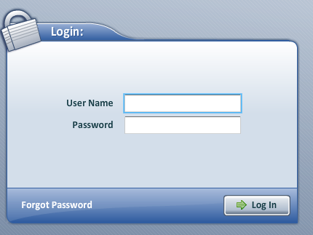

5. The next screen you will see a menu with 4 options: “Start/Join session”, “Monitor Interface”, Debrief Sessions”, and “Administration”.
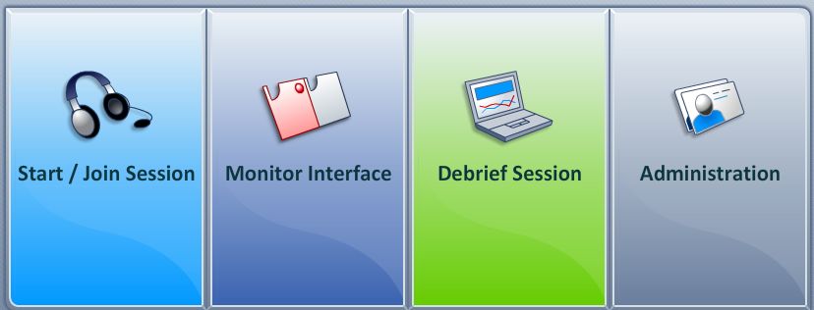
6. Choose “Administration”.

7. The next screen has 4 options: “Users, Courses, Scenarios, and Evaluations”.
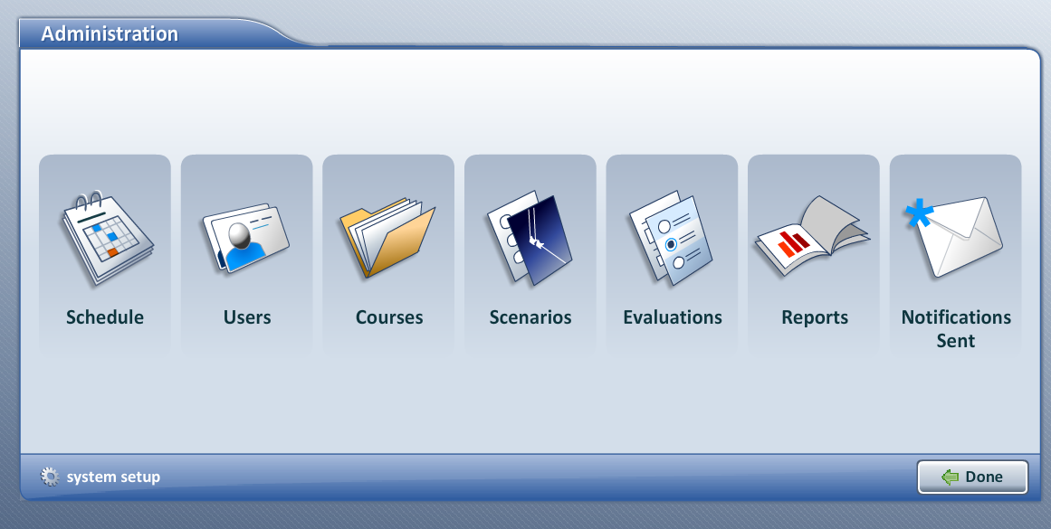
8. Choose “Courses”. This will open up a list of courses.
9. Click on your last name that is associated with the nursing course you are teaching. Note: If you are teaching more than one section, all of your students for all sections will be found under your name. Here is an example:
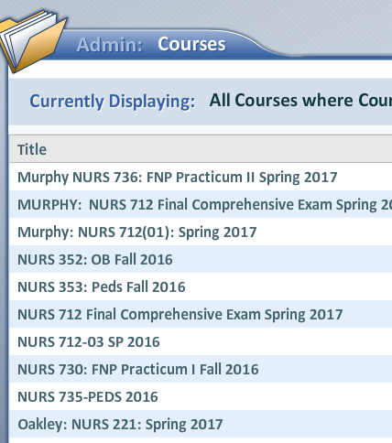

10. At the top of the screen, there will be 6 different tabs to choose from: “Summary, Curriculum, Users, Attachments, Sessions, and Release Settings”.
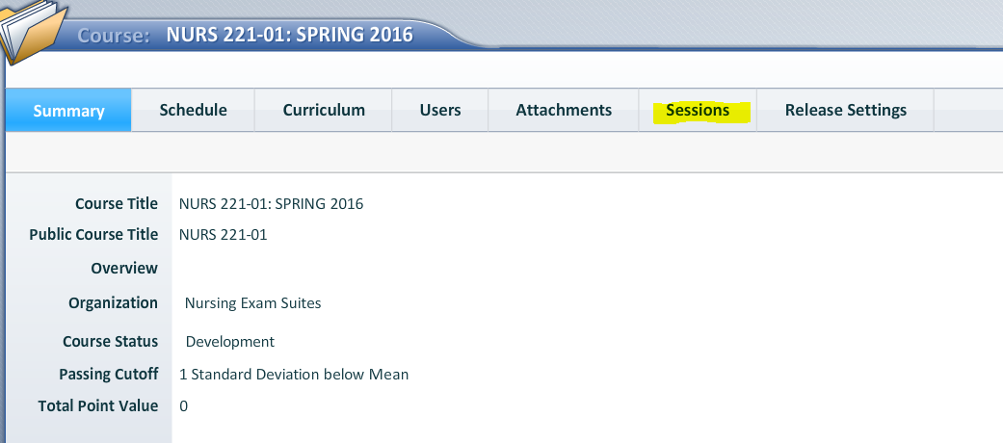
11. Choose “Sessions”.
12. This will open a listing of all filmed sessions that have been recorded for your course and section. The list shows the name of the scenario, the session participants, the date the session was filmed, and the duration of the film.
13. To find your student, just look for their last name in the list. (Note: If an SP was used in the case, the SP’s last name will show next to your student’s last name).
14. Double click on the session you would like to view, and it will bring up the video.
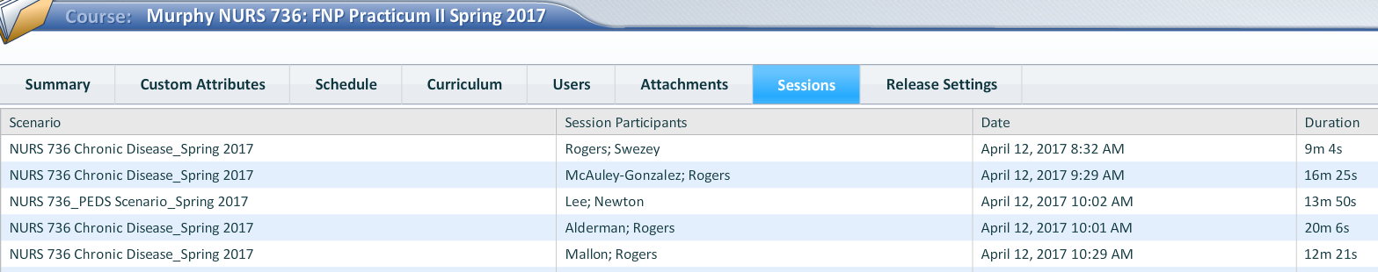

15. Once the video is open you can expand the video to a full screen view if desired -click on the small black and white box beside the “Annotate” button to the middle right side of the screen to expand the video to full screen.
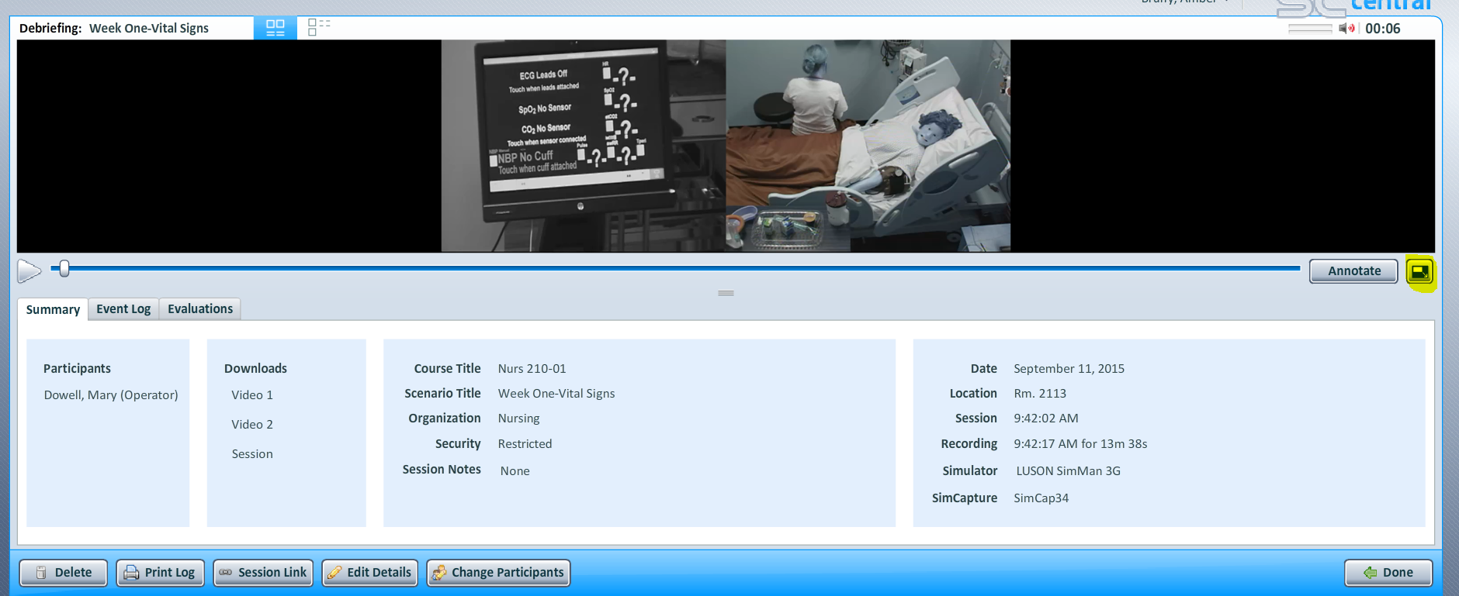
16. Once the video is being displayed in full screen, you can hit “esc” on your keyboard to exit the full screen view.
17. When you are done viewing the video, make sure it is in the small screen view to exit. Once you are in the smaller display for the video you should see a button with the word “done” on it with a green arrow pointing to the left in the lower right hand corner of the screen. Click this button to be taken back to your course. (*If you do not see the “Done” button in the lower right hand corner you may have to drag your screen view down to get it to appear.)
19. This will take you back to your course home screen. You will need to click on “sessions” again, and choose another student to view the next video.
**If you find you are missing a student video in your list, please e-mail Mrs. Amber Bruffy at anbruffy@liberty.edu. Office Number: 434-592-5407

B-Line Questions?
Contact:
Amber Bruffy, MSN, RN
DNP FNP Simulation Center Director
Liberty University School of Nursing
434-592-5407
anbruffy@liberty.edu

