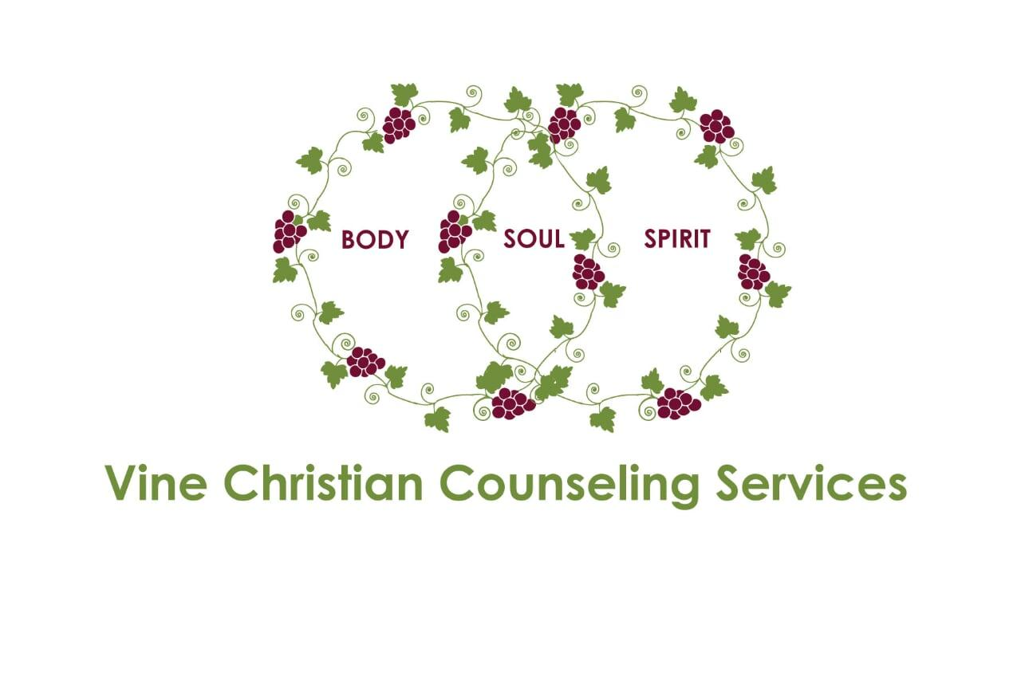
Internship Opportunities
Vine Christian Counseling Services, PLLC, is offering internship opportunities and/or post graduate employment positions.

What we do:
You can find our website at www.Vineccs.com for more information. In a nutshell, we offer evidence-based therapy from a Christ-centered worldview. We are not merely therapists who happen to be Christians. We are Christians who happen to be trained in psycho-therapy. We meet our clients where they are and help to facilitate movement in their spiritual journey, emotional and mental journey, and behavioral journey. We utilize techniques such as Motivational Interviewing, CBT, DBT, Psycho-education, EMDR, Mindfulness (from a Christian worldview) and the Gottman Method for couples. Currently, we are only providing tele-health, but will be securing a new office in May or June, so we will be ready for in-person sessions as well.

What we offer:
Vine CCS offers a Christ-centered work environment that is supportive, loving and respectful of staff and clients. We actually become friends/family.

We create environments where learning is facilitated and encouraged; ongoing training is achieved at an individual and organizational level.

We offer the freedom of setting schedule, including deciding on when our clinicians will take
holidays, and sick days without condemnation. Your work day will begin and end according to your needs.

We offer the freedom for our clinicians to choose their unique methods and niche.

We offer supervision for LMHC’s in Iowa as well as any pursuing CADC supervision.

If you are interested and would like more information, feel free to email or call.

Monique Maldonado, LMHC, MACP, IADC
515-420-0520 PH
515-606-3523 Fax
Vineccs@protonmail.com

