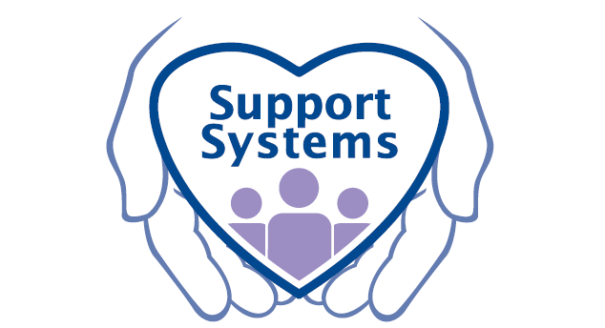
Are you looking to make
A Difference in Someone’s life?

Do you believe everyone should
Have the opportunity to live
Their best life?

Then come join Us!

Support Systems, Inc. is looking for qualified candidates for immediate consideration for our Mental Health Clinician positions in our Roanoke, Lynchburg and Rocky Mount Offices. Individuals with a bachelors degree and at least one year of experience working with and providing treatment to individuals with mental illness may qualify for this flexible and rewarding position offering excellent pay and benefits and both full time and part time opportunities. This position provides individuals with great opportunities with a growing company and allows individuals to make their own schedule while helping others to live their best life through support and guidance of a qualified mental health professional. Excellent supervision and support are provided along with paid vacation, holidays, sick time, health, dental, vision and short term and long term disability benefits. Mileage stipends are provided to assist with driving expenses and sign on bonuses are available. For more information or to apply please contact Jennifer Gobble at 540-293-4400 or at jdgobble@yahoo.com OR 540-767-2667 or visit our website at www.supportsystemsvainc.com for more information about Support Systems and what we do.

