Introduction:

The following information is a concise summary of the FAA requirements to qualify for the Airline Transport Pilot Certificate with Reduced Aeronautical Experience (R-ATP*). As professional aviators, we are held accountable for adherence to FAA guidelines. This information sheet does not relieve pilots of their individual responsibility to take ownership of their education and their knowledge of the FAA requirements to qualify for the R-ATP. For complete FAA R-ATP guidelines refer to FAA AC 61-139 and FAR 61.160.

Note: For brevity, the acronym “R-ATP” is used in place of the proper FAA designation of “restricted privileges ATP”.

Current LOA:

- Amendment No. 19:
  - Effective 5 Dec 2025, the LUSOA received additional authorization from the FAA updating the list of FAA approved aviation related coursework and FTAs.

*Note:
  - New FTAs are frequently being added to LUSOA’s growing list of approved training locations.
  - Not all of the LUSOA FTAs are currently approved for the R-ATP.
  - Future LOA amendments will include the new FTAs.

The LUSOA is authorized by the FAA to certify its graduates for both the 1000 Hour and 1250 Hour R-ATP.

To be eligible for the FAA R-ATP, a graduate must meet FAA mandated certificate, academic and flight training requirements.

Certificate Requirements:
- FAR 61-160(b)3
  - “Hold a commercial pilot certificate with an airplane category and instrument rating.”

Academic Requirements:
- Approved Liberty University Aviation Degrees:
  - Bachelor of Science in Aeronautics
  - Bachelor of Science in Aviation
  - Bachelor of Science in Aviation Administration / Flight Cognate
  - Bachelor of Science in Aviation Technology: Flight and Maintenance
- For the 1000-hour R-ATP: Complete 60 credit hours of aviation and aviation-related coursework that has been recognized by the Administrator.
- For the 1250-hour R-ATP: Complete 30 credit hours of aviation and aviation-related coursework that has been recognized by the Administrator.

Note:
Approved residential and online courses can be applied to satisfy the FAA coursework requirement.
  - Prior Learning Assessment (PLA) credits cannot be applied to satisfy the FAA coursework requirement.

PLA Defined: PLA is an assessment of prior experiential learning and is an academic term used to describe learning attained outside of a typical academic environment.
  - PLA course credit is assigned for FAA Certificates and Ratings completed outside of Liberty University. (i.e: Private Pilot Certificate / possible 12 PLA Credit Hours)
  - PLA course credit from a non-FAA R-ATP approved institution of higher learning may be used as a suitable course substitute to satisfy academic graduation requirements. (But does cannot be applied to R-ATP academic credit hour requirements)

    - To receive FAA R-ATP course credit the course must be listed under “Aviation Approved Coursework” in the Liberty University FAA R-ATP LOA and also included under “Institution Credit” on the student’s official Liberty University transcript.

    - To be listed under “Institution Credit” students must have been officially registered for and enrolled in the course for a grade.
      - Auditing a course does not meet the requirement.

    - To receive FAA R-ATP course credit for instrument and commercial flight courses, students must be officially registered at Liberty University for Instrument Flight (AVIA 320) and Commercial Flight (Normally, AVIA 325, 326, and 327 or AVIA 322 and 324).

    - Students who complete the 14 CFR Part 141 instrument and commercial flight training courses but were not officially registered at Liberty University for Instrument Flight (AVIA 320) and Commercial Flight (Normally, AVIA 325, 326, and 327 or AVIA 322 and 324) will not be eligible for FAA R-ATP.

  - University graduation requirements vs. FAA R-ATP requirements
    - While PLA credit may be applied in certain cases to satisfy university graduation requirements, PLA credit does not satisfy the FAA coursework requirements for the R-ATP and in some cases results in ineligibility for the R-ATP.

    - Fulfilling the Degree Completion Plan (DCP) graduation requirements for any of the FAA-approved Liberty University degrees will not guarantee that you meet the FAA R-ATP requirements. You must ensure that you complete the required number of credit hours in FAA-approved courses.

  - FAA-approved coursework completed after the FAA-approved degree has been conferred cannot be applied to the 30/60 credit hour coursework requirement.

Ground / Flight Training Requirements:

- IAW 14CFR61.160, the graduate must have obtained a commercial pilot certificate with an airplane category and instrument rating from a 14 CFR Part 141 pilot school associated with an institution of higher education.

  - Complete the required Instrument (AVIA 310) and Commercial (AVIA 315) ground training as part of an approved 14 CFR Part 141 curriculum at Liberty University.

  - Complete the required Instrument (AVIA 320) and Commercial (Normally, AVIA 325, 326, and 327 or AVIA 322 and 324) flight training as part of an approved 14 CFR Part 141 curriculum at the LUSOA or at an approved 14 CFR Part 141 flight school that has an FTA agreement with the LUSOA as stipulated under 14 CFR §141.26

  - The ground training courses and flight training courses must be completed concurrently.

    - Concurrently is interpreted to mean the ground training must be completed either the semester prior or in the same semester as the associated flight training.

  - There is no provision in place for transferring partial Instrument or Commercial flight training between approved flight schools.
    - Any student who begins Instrument or Commercial flight training at one approved flight school and then transfers to another must start over and complete the entire approved TCO (Training Course Outline) flight training for certification.

Note:
  - Students are not eligible to apply for the R-ATP Certifying Certificate until they hold an FAA Commercial Pilot Certificate and their B.S. Degree (Aeronautics, Aviation, or Aviation Administration, Flight Cognate) has been conferred. Prior to graduation, students should conduct a review of their records to ensure they have met all requirements.
  - Graduates who apply to a DPE to take the ATP practical test using the provisions of 14CFR61.160 (restricted privileges ATP) will be required to provide their:
    - Official academic transcript from their LOA-holding university
    - 61.160 R-ATP certifying statement (R-ATP Certificate).

Transfer Students:
- AC 61-139 does provide a provision for students transferring between Authorized Institutions of higher learning.
  - Both institutions must be authorized to certify its graduates for the

R-ATP per FAR 61.169.
  - The student must provide an official transcript and a copy of the FAA R-ATP Letter of Authorization from the institution initially attended.
  - Courses to be transferred must be included on the FAA Authorized Aviation Coursework List from the institution initially attended.
  - To avoid duplicating course credit, in some cases a course syllabus may be required.

Note:
- Both Instrument Ground and Instrument Flight, or Commercial Ground and Commercial Flight, must be completed concurrently at one approved institution.
- There is no provision for transferring partial Instrument or Commercial ground or flight training between approved institutions.
- Prior Learning Assessment (PLA) credits cannot be applied to satisfy R-ATP course requirements.
- Ref: AC 61-139,12b. Transferring Between Authorized Institutions of Higher Education

R-ATP Application Procedures:

- Liberty has now implemented an automated R-ATP application process.
- Both residential and online students should make their application for the R-ATP Certifying Statement via their Liberty email account to:
  - https://apex.liberty.edu/banprd/f?p=253:14:::NO:RP:FORM_NAME:AVIATION_RATP

Note:
    - The normal processing time is 2-3 weeks.
    - Non-Liberty email addresses will not be recognized by the new automated system.
    - Graduates are eligible to apply as soon as their degree has been conferred by the Registrar’s Office.
    - Graduates applying for a R-ATP should not wait until:
      - They have a scheduled airline class date
      - Building the appropriate amount of flight time

    - The time required to process the R-ATP Certifying Certificate could actually delay your airline interview/class date.
- With the exception of the LU Official Transcript, all required documentation should be uploaded into the automated system.
- LU Official Transcript Requirements:
  - Transcript must have “Degree Awarded” statement with awarded date. (See example below)

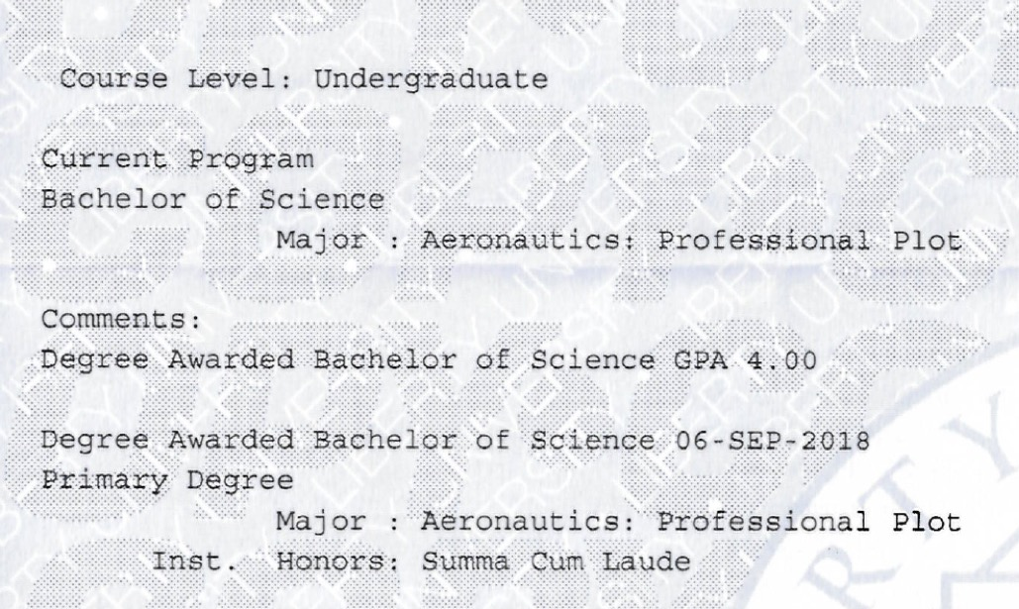

  - NEW Update: Graduates now have the option of providing either a traditional paper transcript or electronic e-script transcript from the Registrar’s Office for their R-ATP application.
  - For traditional paper transcripts:
    - Request 2 official copies of your transcript from Registrar’s Office
    - Official transcripts must be in a sealed envelope, stamped “Official” by the Registrar’s Office, with your name on the outside.
  - Residential (RES) Graduates:
    - Have the Registrar send one copy of your official transcript to:
Jonathan Hoppe
Liberty University
School of Aeronautics
1971 University Blvd
Lynchburg, VA 24515
  - Online (LUO) Graduates:
    - Have the Registrar send one copy of your official transcript to:
Jonathan Hoppe
Liberty University
School of Aeronautics
1971 University Blvd
Lynchburg, VA 24515

  - For electronic e-script transcripts:
    - Email to:
      - RES Graduates: ratpresidential@liberty.edu
      - LUO Graduates: ratponline@liberty.edu
  - Note: For all graduates:
    - For your FAA R-ATP checkride
    - You’ll need to present an official paper transcript to the FAA Examiner.
    - This copy must be in a sealed envelope, stamped “Official” by the Registrar’s Office, with your name on the outside.

- When all the required documentation is received the R-ATP will be processed.

-----The End-----

